# **Create a instance**

1. Open command prompt – **ctrl+r** and write **cmd.**
2. Jis folder main instance ki key file hai vo folder ko select kare. (download)
3. **Cd download** type on cmd
4. copy example command from ssh client from instance example **(ssh -i "firstwebsite.pem"** [**ec2-user@ec2-65-0-98-116.ap-south-1.compute.amazonaws.com**](mailto:ec2-user@ec2-65-0-98-116.ap-south-1.compute.amazonaws.com)**)** ye link milegy instance par click kare k baad coonect par click kare fir SSH client select kare scrool kare link mil jaegy. Jaise hi enter karegy linux main enter ho jaegy .
5. than linux main (**sudo su** command likhegy toh app root user ban jaegy).
6. yum install httpd* -y (is se httpd install hoga )
7. mkdir folder-name (se ek folder banega)
8. chmod 777 folder-name (folder ko permission milegy)
9. pwd ( show hoga /home/ec2-user)
10. ls (se folder show hongy)

terminal-2

>cd downloads (jaha key ha .pem wali)

>scp -i "key.pem" "zip file name" ec2-user@[public dns aws se copy kr ke paste krna haa]:a

again go to terminal 1

#cd a -- going in dir a

#ls

here u find the zip file

#unzip (filename.zip)

then copy the folder to /var/www/html

#cp -r (folder name)/* /var/www/html -- copy the code file to html folder

then

#systemctl start httpd

boom!!! lets check your websitee with your ip

#rm -rf /var/www/html/* -- delete things in html folder only not html folder.

#rm -rf (name) --- to delete anything permenat

WESBSITE HOSTING WITH DOMAIN

1. First host website normal
2. Come to godaddy and
3. Manage -- > dns 🡪 nameserver🡪change
4. Come to instance 🡪 route 53 🡪 create hosted zone 🡪domain 🡪 create🡪 CREATE🡪 AND THAN

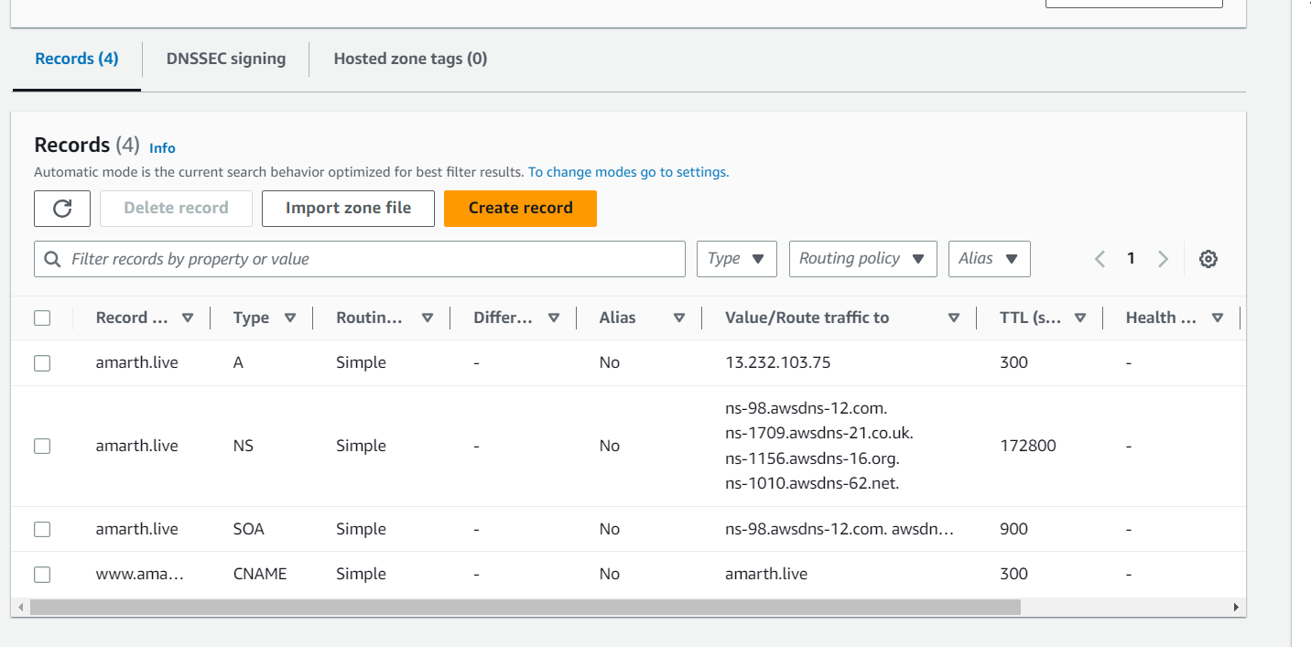

COPY PASTE ALL 4 VALUE/ROUTE TRAFFICE TO

ns-98.awsdns-12.com.  
ns-1709.awsdns-21.co.uk.  
ns-1156.awsdns-16.org.  
ns-1010.awsdns-62.net.

EDIT nameserver🡪 and copy paste all 4 link and save ns-98.awsdns-12.com.  
ns-1709.awsdns-21.co.uk.  
ns-1156.awsdns-16.org.  
ns-1010.awsdns-62.net.